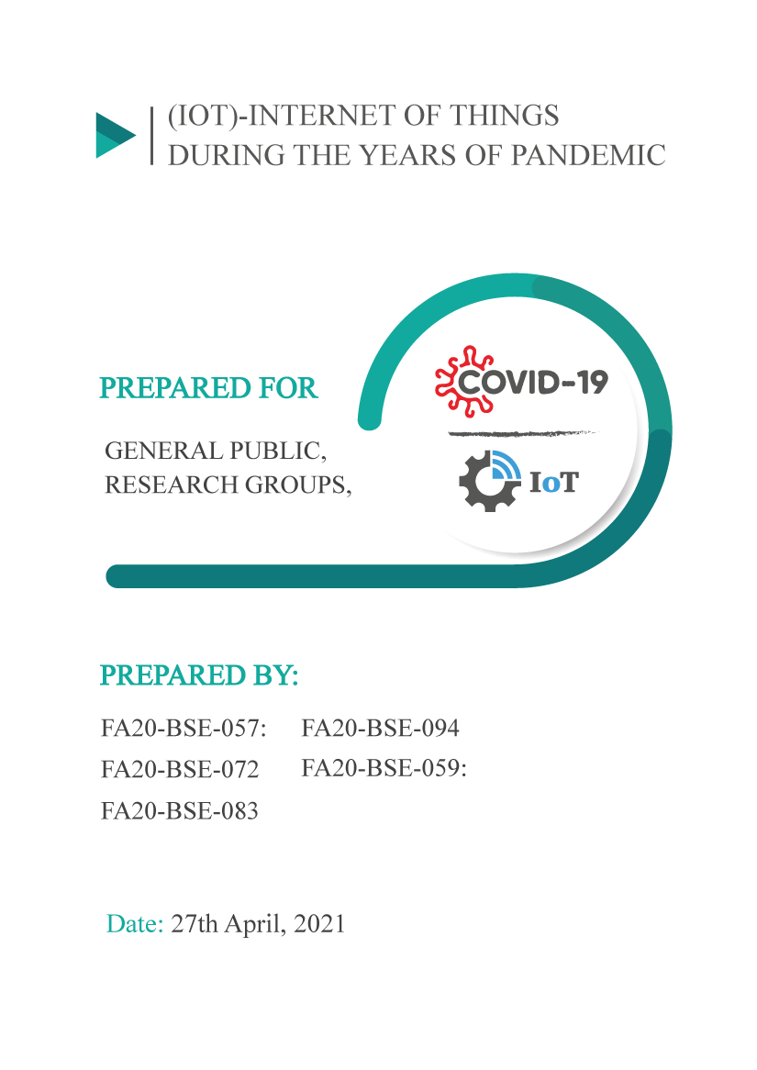

# **Abstract:**

The aim of this report is to inform the general audience about the role of (*Internet of things*) IOT-based technology in field of health and different fields for public interaction in this chaotic period of **COVID-19**. The **IOT** revolution recreates modern healthcare systems, including technical, economic, and social prospects. Data from certified and verified sources like research and journal articles and reviews are used as a secondary source for information in this report. It explores the expansion and growth of IOT, as well as its implementation in various areas of application. The main areas covered in this study include healthcare, business, education and economy. Moreover, the main focus of this report is to tell general audience that what are the impacts of Covid-19 on technology and how IOT is helping to deal with this pandemic. The results of IOT against this pandemic plays vital role in damping their effects on society. Also experts fear that the pandemic’s economic fallout will considerably upset the **PAKISTAN’s** recovery process. All the educational institutions uses IOT based technology to keep learner safe and engaged in education during a pandemic. The Scientists of the world are starting to roll out COVID-19 vaccines. People were on the verge of chaos due to coronavirus. Being a third world country chaos was found in every aspect either it was educational, health, business or economic sector but at this scenario IOT (internet of things) have been efficiently dealing with this critical situation. Internet of things is not a concept rather it is the network, the true technology enabled network of all networks. A country must implement more IOT based technologies to prevent corona and reduce the risk of death ratio. Establish online video boot camp for the people to increase the knowledge about IOT technologies in Pakistan.

Table of Contents

Abstract: 2

1. Introduction: 4

1.1 Background Information: 4

1.2 Purpose: 4

1.3 Significance of study: 4

1.4 Scope of Study: 4

1.5 Limitations: 5

2. Literature review: 5

3. Methods of Study: 6

3.1 Sources: 6

3.2 Criteria: 6

4. Results & Discussion: 6

4.1 Business & IOT: 6

4.1.1 IOT in business: 6

4.2 IOT & Education: 8

4.2.1 Applications for virtual education: 8

2.2.2 Infographics of Application Usage: 9

4.3 Economy of Pakistan: 9

4.4 Health sector & IOT: 10

2.4.1 Research and inventions: 10

4.4.2 Applications of IOT in healthcare: 11

5. Conclusions: 11

6. Recommendations: 11

References 12

**Table of Figures:**

Fig 1 IOT Market 7

Fig 2 Implementation line 8

Fig 3 IOT Interaction rate 8

Fig 4 knowledge retention rate 9

Fig 5 Apps 9

Fig 6 loans during COVID 10

# **1. Introduction:**

## 1.1 Background Information:

Coronavirus is a family of viruses that ranges from common cold to Severe Acute Respiratory Syndrome (SARS). It was first detected in Wuhan, China in December 2019. Isolation, contact limitations and economic shutdown impose a complete transformation of ecosystem. The economy of the world, educational and business sectors are at great risk.

Any object that can be connected to the internet to continue monitoring or translating data can be an IOT (Internet of thing) device. IOT technology has shown to be an efficient way of dealing COVID pandemic.

## 1.2 Purpose:

The objectives includes informing the general audience about the role of IOT-based technology in field of health and different mediums for public interaction.

The IOT revolution recreates modern healthcare systems, including technical, economic, and social prospects. Even if these dangerous viruses can’t be barred from appearing, then there should be a medium for dampen their effects on society.

## 1.3 Significance of study:

Internet of things includes the devices that includes a wide range of abilities i.e. tracking, authentication, manipulation of data through which patients can be diagnosed and treated. Not only in health sector, but it also has a range of applications in military, education, security, transportation, agriculture etc. that helps in everyday life.

## 

## 1.4 Scope of Study:

The extent of this report cover a great influence of modern technology towards COVID pandemic. The scope of this report includes:

* The progressive research of technology toward the pandemic.
* Understanding technology adaption in business & educational sector.
* Restriction and Isolation is utmost important. This scope will cover the contribution of IOT for collaborations and interaction between general public, students and businesspersons.
* Emphases on technological achievement.

## 1.5 Limitations:

Due to the ongoing contagion, the usage of IOT is in excess. There are some specific limitations that might be undesirable for common person.

* Heedless knowledge of technology which leads a common person to trouble in online interactions.
* Spamming through internet is a serious issue to be acknowledge.
* Lack of technology required for COVID controlling.

# **2. Literature review:**

* **EHSAS Today:**

COVID-19 pandemic has affected every aspect of life which caused businesses to use industrial IOT system combined with cloud and analytics. Businesses like restaurant, data center, industries etc. are now dependent on IOT technology which help to support their goals. (ehsas, 2021)

* **Springer Link:**

During this chaotic situation majority of students rely on IOT apps which provides them a safer and comfortable way to get education. Now education is not only confined to combination of text and images, but with help of IOT we can clarify the concept of students through graphics, videos and interactive gamification. (springer, 2021)

* **IOT for all:**

The health care industry understood the advantages of IOT even before the pandemic situation. According to survey IOT improved the efficiency of manufacturing of medicine by 81% due to which more people get vaccinated in less time. Hospitals also use IOT devices to spot illness and ailment in patient and to improve the efficiency of their record-keeping process. (IoT for All, 2021)

* **THE WORLD BANK:**

As we know that current pandemic situation is a great threat to economy, for example Pakistan GDP in 2018 was 5.8% and now it is 0.98%. All this is due to lack of adoption of IOT by business sector. Through IOT we can increase productivity as much as 0.2% of GDP and the estimate also suggest that IOT will contribute approximately 4-11% of total world GDP in 2025. This will surely have great impact on both consumer and industry. (The World Bank In Pakistan, 2021)

# **3. Methods of Study:**

## 3.1 Sources:

Data from local and international creditable organizations are used as the primary source of information for discussion and findings in the report. Data from certified and verified sources like research and journal articles and reviews are used as a secondary source for information in this report.

## 3.2 Criteria:

Only information from well known, empirical, and reputable sources was considered for this report. Any sources or data that have not been processed were found to be faulty and were dropped. Data was substantiated across multiple sources before being added.

In this report, we systematically classify and investigate the definitive research procedures regarding IOT application methods and approaches in different fields during the years of pandemic. After collecting the data, we compared it in descriptive and graphical form and then have shown the results of the comparison. The main areas covered in this study include healthcare, business, education and economy. Moreover, the main focus of this report is to tell general audience that what are the impacts of Covid-19 on IOT and how IOT is helping to deal with this pandemic.

# **4. Results & Discussion:**

## **4.1 Business & IOT:**

The coronavirus pandemic has placed the spotlight on the Internet of Things (IOT) technology, with many businesses using IOT applications as a means of adapting to the new normal. IOT technology can improve efficiency, quality, and safety for businesses having to cope quickly with major changes. Its implementation can be seen from [Fig 2 Implementation line]

### 4.1.1 IOT in business:

* Transportation for certain products is in high demand:

Demand for trucking services rose sharply, as the demand for medical equipment and groceries rose with COVID-19 infections. IOT systems for trucks can solve this problem, by providing real-time temperature, vibration, and location data. (ehsas, 2021)

* Many restaurants adopt new business models to survive:

Manual temperature checks for coolers and freezers are a challenge to do even when a restaurant is fully staffed. An IOT network with remote temperature sensors can report those readings to managers so they can quickly deal with problems like open cooler doors or malfunctioning equipment. (ehsas, 2021)

* Fever-Kit:

One area IOT is playing a significant role during the coronavirus is in contactless interactions, for example, recently released Fever Kit, a no-touch, portable device designed to screen users for fever. (techrepublic, 2020)

* + IOT Business in North America, see [Fig 1 IOT Market].

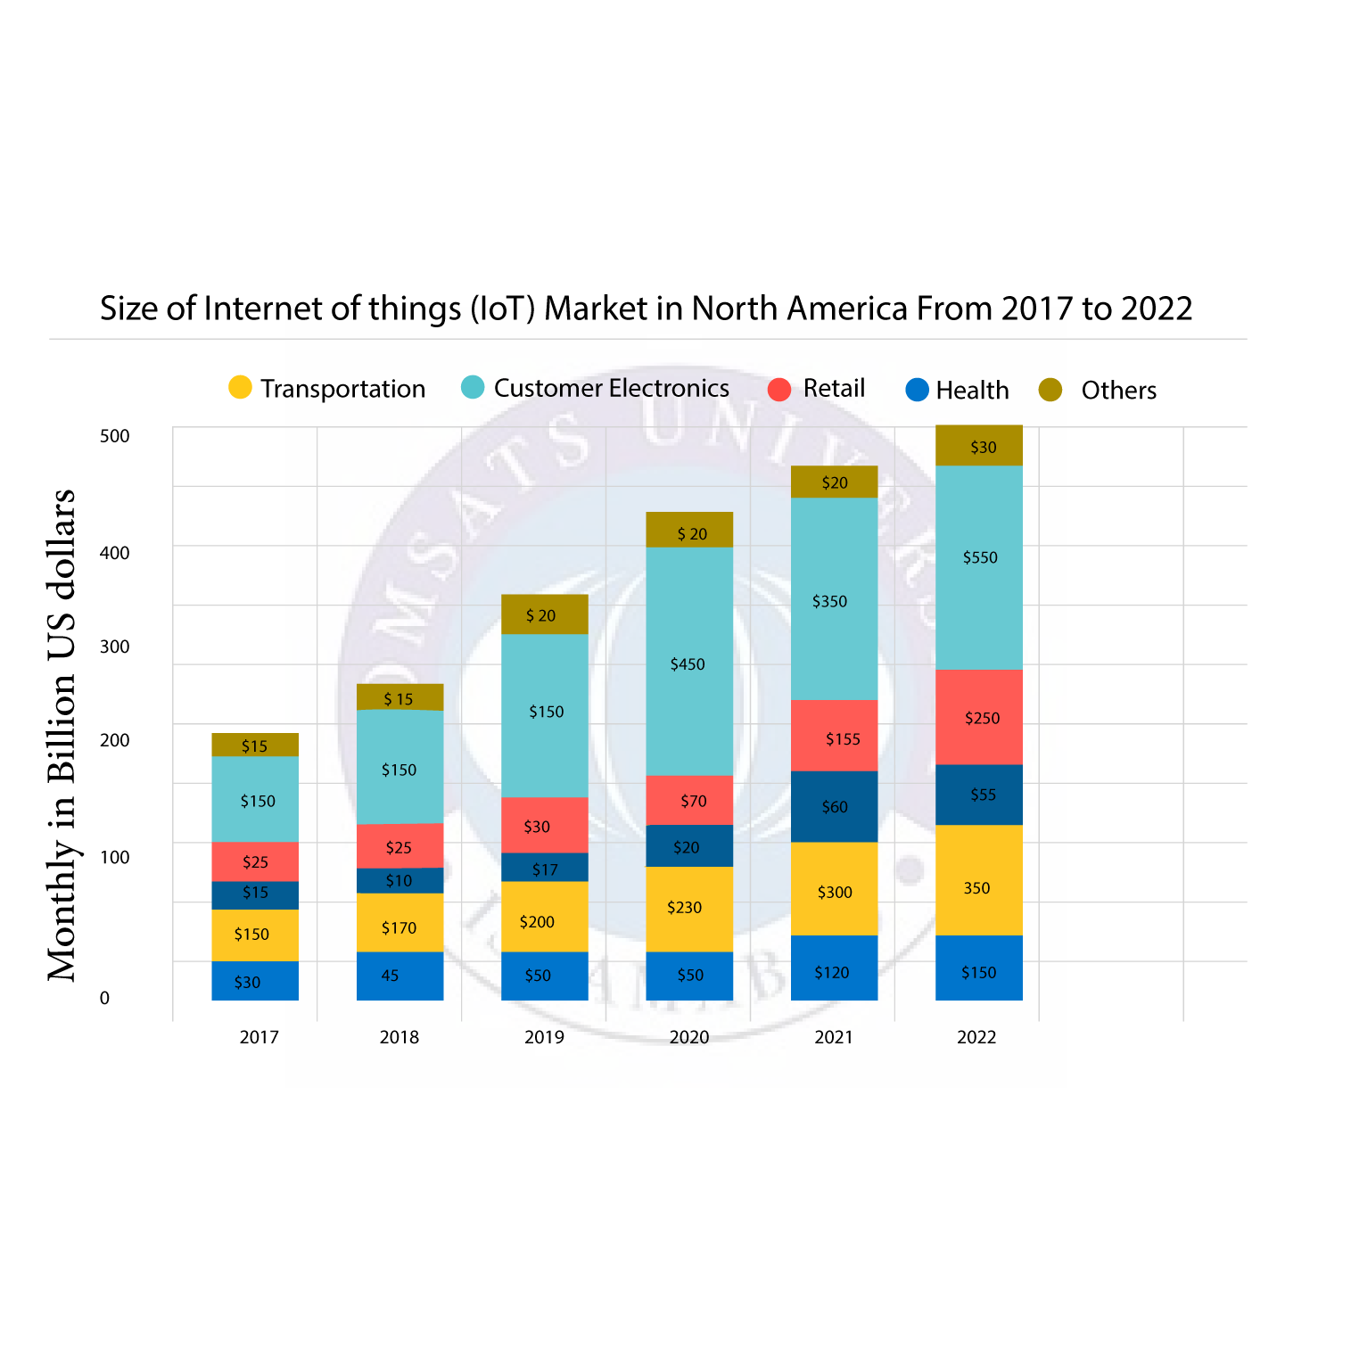

Fig IOT Market

There are many IOT devices and applications like wearables, drones (***Disinfectant*** *Drone,* ***Medical****/Delivery Drone*), robots (*Tele-robots,* ***Collaborative*** *Robots*), IOT buttons, and smartphone applications (*Social* ***Monitoring****, Selfie app*) that are mainly utilized in the forefront of combating COVID-19. The Covid-19 pandemic has forced almost every businesses to change the way they work and their priorities in a matter of weeks, with more than three-quarters of adopters increasing the pace of internet of things (IOT) projects. Despite the disruptive impacts of the Covid-19 lockdown, with 35% of organizations reducing their investments in the internet of things (IOT), a larger number of are now planning to invest more in IOT **implementations** to reduce costs among other benefits. (springer, 2021)

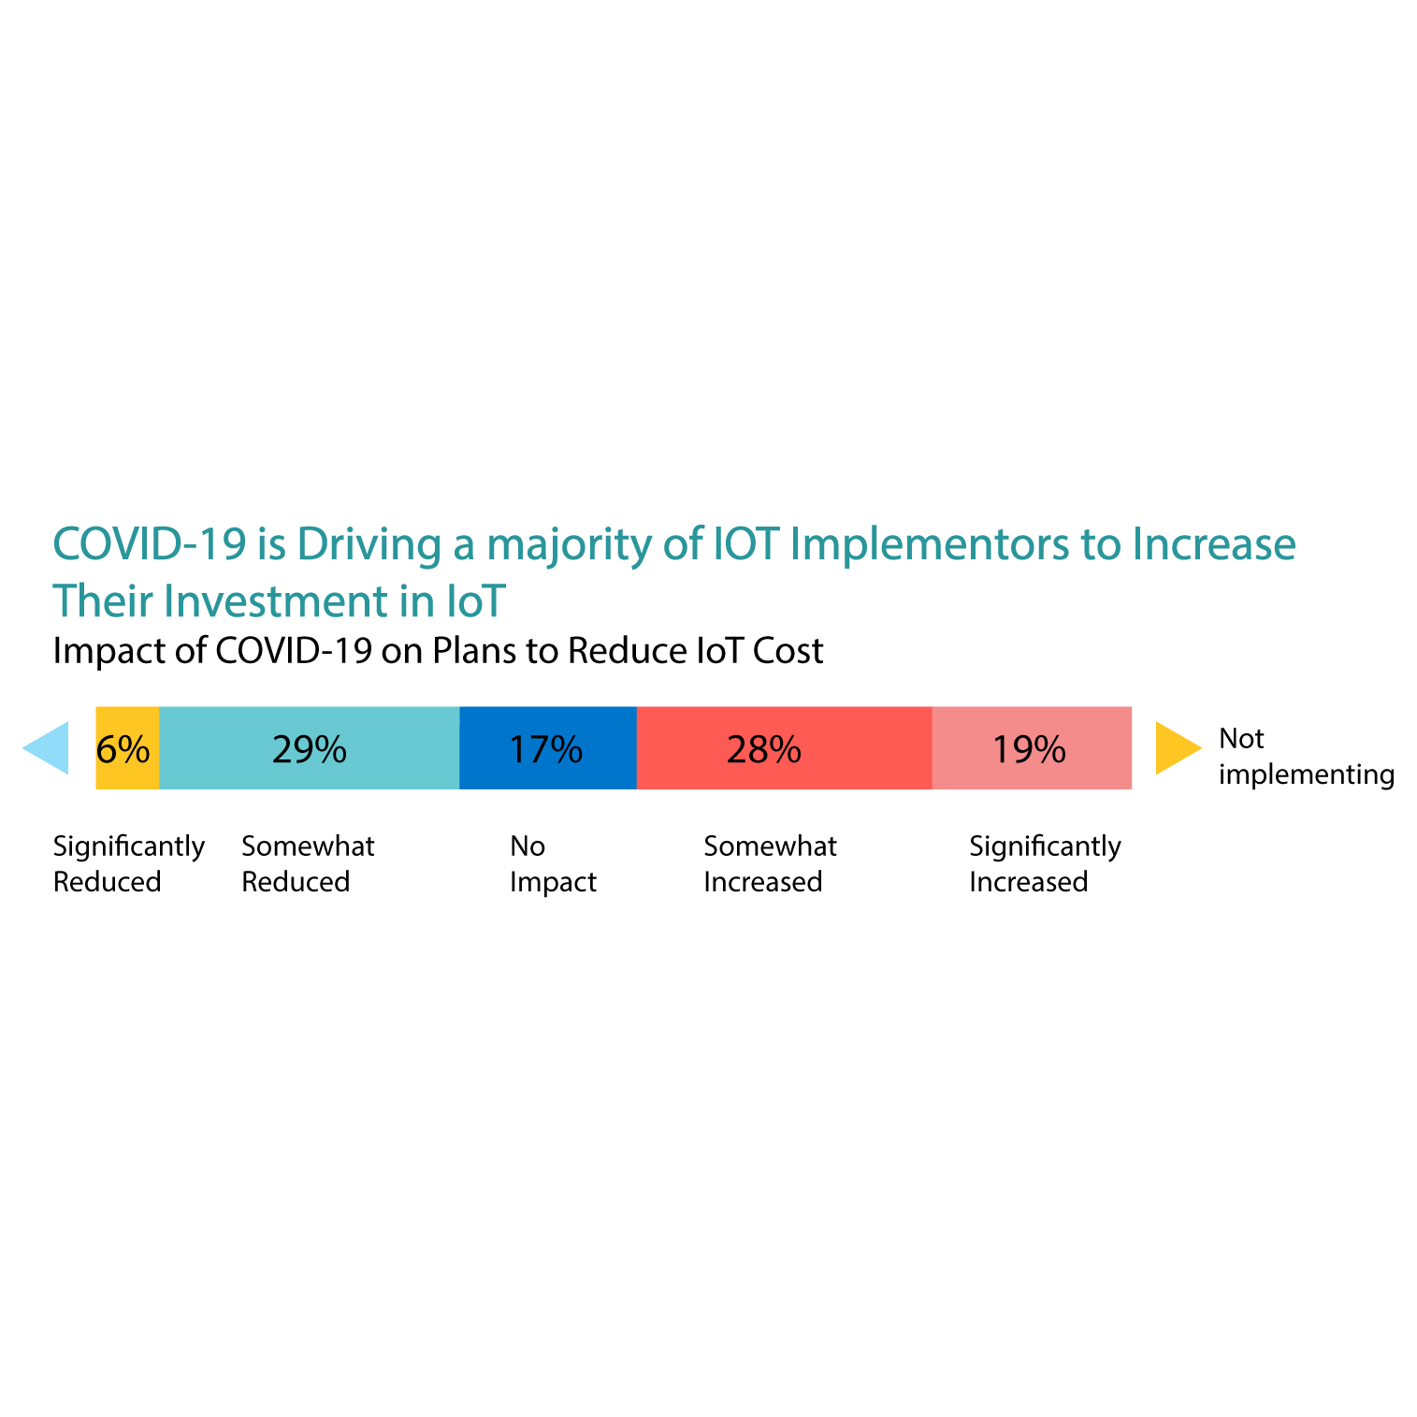

Fig Implementation line

## **4.2 IOT & Education:**

The current pandemic situation has brought a massive change in educational system. All the educational system are inclined to use IOT based technology to keep learner safe and engaged in education during a pandemic. [Fig 3 IOT Interaction rate]

### 4.2.1 Applications for virtual education:

Now majority of students and teacher rely on IOT apps like **zoom**, **Microsoft** **teams** etc. Recent survey says that number of users of zoom and teams increased up to 151% year over year. Microsoft recently said that skype consumer service was 70%, but in this pandemic situation the customer of zoom and teams increased so much that these apps were made top rated. See infographics in [Fig 5 Apps] (GlgInsights, 2021)

These apps provide effective platform for learning and imparting knowledge for both teacher and students. However this can be equally beneficial to physical classes in a way that students and teachers can communicate in informal ways. As with the help of IOT we can further clarify the concepts of students through graphics, videos, discussion and interactive gamification. [Fig 4 knowledge retention rate]

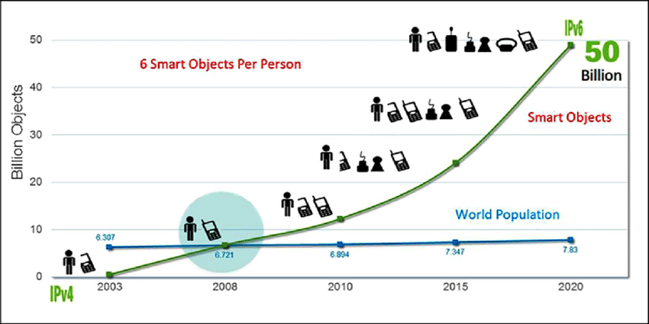

Fig IOT Interaction rate

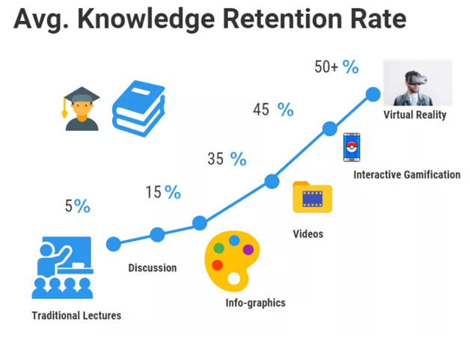

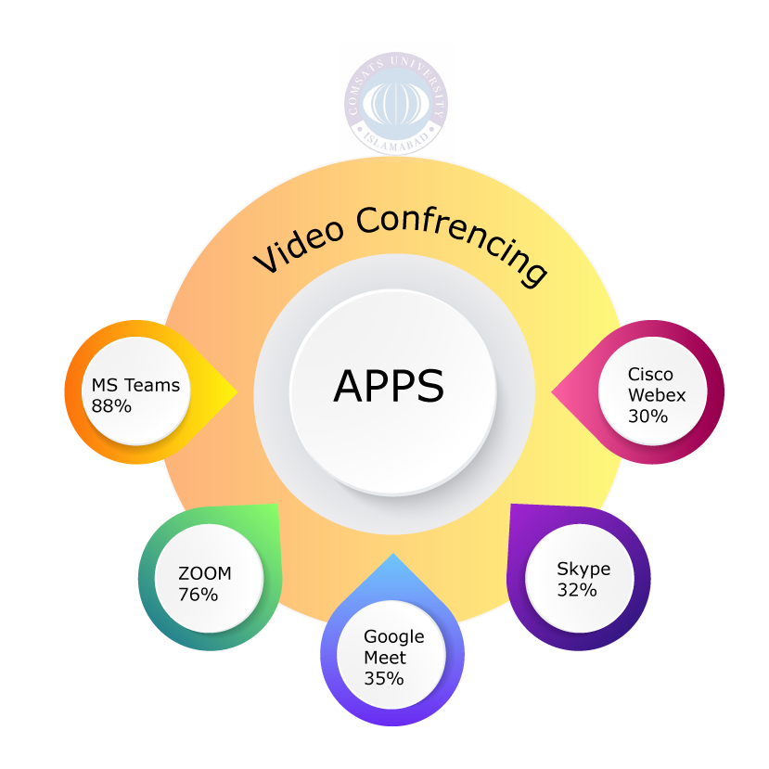

Fig knowledge retention rate

Fig Apps

### 2.2.2 Infographics of Application Usage:

These apps provide effective platform for learning and imparting knowledge for both teacher and students.

## **4.3 Economy of Pakistan:**

**Pakistan’s** already fragile economy had only just been moving towards stability when the health crises struck. **Experts** fear that the pandemic’s economic fallout will considerably upset the country’s recovery process. The pandemic has also taken a devastating blow on the Pakistani economy [Fig 6 loans during COVID]. (DW-Live, 2021). In 2018 Pakistan's **GDP** **growth** was around 5.8%; now it is 0.98% and is likely to decline further. The country's fiscal deficit is almost 10% and revenues have dropped in the past two years. (DW-Live, 2021). Lockdown of offices, markets and industrial sector leads to a fall in sock exchange market. As a result:

* GDP growth is estimated to have contracted by 1.5 percent in FY20.
* Half of the working population saw either job or income losses, with informal and low-skilled workers employed in elementary occupations facing the strongest loss in employment.
* In Pakistan the poverty incidence is estimated to have increased from 4.4 to 5.4 percent (The World Bank In Pakistan, 2021).

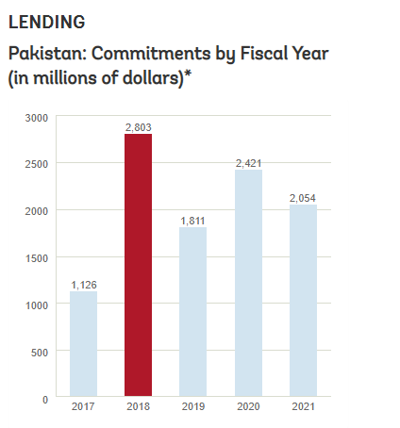

Fig loans during COVID

## **4.4 Health sector & IOT:**

### 2.4.1 Research and inventions:

After nearly a year of fighting the pandemic, the **Scientists** of the world are starting to roll out COVID-19 vaccines. As daily infections continue to climb and lockdowns take their toll on people’s lives, an effective vaccine rollout becomes more critical. **Technology** specifically the Internet of Things (IOT) is helping authorities with that. IOT devices in a manufacturing plant can gather data that shows how the facility can become more efficient. In a 2019 PWC survey, 81% of industrial manufacturers said IOT had improved their efficiency. These gains help vaccine producers maximize their output, helping more people get vaccinated in less time. IOT devices can help after patients receive their **vaccinations**, too. Many people already use health wearables like smartwatches, so using these devices to track their vaccinations is straightforward. Thanks to these devices, manufacturers, hospitals, and authorities can ensure effective vaccine rollouts and hopefully end the pandemic. (IoT for All, 2021)

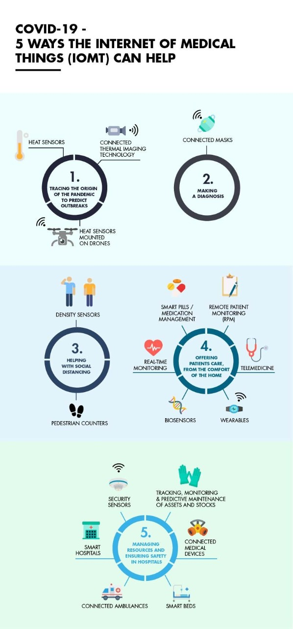

Fig Healthcare tips

### 4.4.2 Applications of IOT in healthcare:

The rise of IOT is exciting for everybody due to its different scope of use in various sectors. In. IOT in healthcare helps in: [Fig 7 Healthcare tips]

* Reducing emergency room wait time
* Tracking patients, staff, and inventory
* Enhancing drug management.
* Ensuring availability of critical hardware. (pperbits, 2021)

# **5. Conclusions:**

People are on the verge of chaos due to coronavirus. Being a third world country chaos was found in every aspect either it was educational,health, business or economic sector but at this scenario IOT(internet of things) have also been efficiently dealing with the critical situation. Education sector took a great advantage of it to make sure that students are gaining knowledge being safe. All the educational system are inclined to use IOT based technology to keep learner safe and engaged in education during a pandemic [Fig 4 knowledge retention rate]. From the statistical analysis Trade and **E-commerce** have rapidly progressed during this pandemic. People have switched from bulk buying to online shopping. The Covid-19 pandemic has forced almost every businesses to change the way they work and their priorities in a matter of weeks, with more than three-quarters of adopters increasing the pace of internet of things (IOT) projects [Fig 5 Apps]. Covid-19 have switched people to new normal conditions. Economy is being terribly suffering and has given birth to the cancer of **poverty**, **joblessness** and other social issues. Experts fear that the pandemic’s economic fallout will considerably disorganize the country’s recovery process [Fig 6 loans during COVID].

# **6. Recommendations:**

* The business sector should combine the IOT technology with other emerging technologies, such as **AI, VR, AR, robotics**, and **block-chain** so that they could minimize the negative effects of such pandemics on their businesses and with the aid of IOT they will be able to unlock previously untapped revenue, gain new competitive advantages, create new training methods, and will produce higher quality products and services.
* A country must implement more IOT based technologies to prevent corona and reduce the risk of death ratio. Establish online video boot camp for the people to increase the knowledge about IOT technologies in Pakistan.
* Intelligent data interpretation can assist epidemiological scientists in anticipating clusters, and can enable them to take necessary action in improving public health management.
* Intelligent data interpretation tools can assist scientists in anticipating masses, and can enable them to take necessary action in improving public health management. This proposed tool could also be used to control disease rate in future global health crises.

# **7. References**

(2020). Retrieved from techrepublic: https://www.techrepublic.com/article/how-iot-is-helping-businesses-navigate-covid-19/

(2021, March 29). Retrieved from The World Bank In Pakistan: https://www.worldbank.org/en/country/pakistan/overview#3

(2021). Retrieved from springer: https://link.springer.com/article/10.1007/s41666-020-00080-6

(2021). Retrieved from ehsas: https://www.ehstoday.com/safety-technology/article/21130849/how-iot-is-helping-businesses-adapt-to-pandemicrelated-disruption

(2021). Retrieved from IOT-world: https://www.iotworldtoday.com/2021/02/26/iot-remote-monitoring-helps-enterprises-traverse-covid-19-and-beyond/

(2021). Retrieved from IoT for All: https://www.iotforall.com/the-role-of-iot-for-the-covid-19-vaccine

(2021). Retrieved from pperbits: https://www.peerbits.com/blog/internet-of-things-healthcare-applications-benefits-and-challenges.html#:~:text=IoT%20can%20automate%20patient%20care,makes%20healthcare%20service%20delivery%20effective.

(2021). Retrieved from GlgInsights: https://glginsights.com/articles/zoom-microsoft-teams-and-slack-have-exploded-due-to-the-covid-19-pandemic-can-they-hold-onto-this-growth/

*DW-Live*. (2021). Retrieved from https://amp.dw.com/en/how-the-covid-19-crisis-is-affecting-pakistans-economy/a-54292705